P Sai Koushik
2200032991
TASK7 Exercise 2: Verifying Interactions
OUT PUT

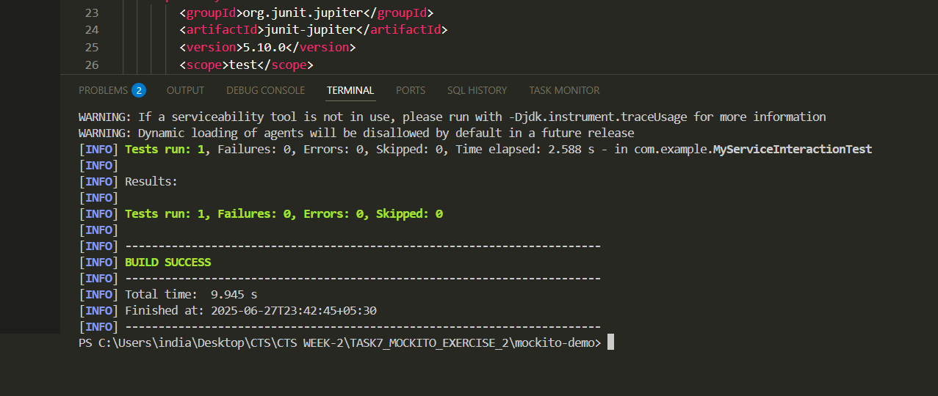

FILE
